Ques 1 Create HTML for web-page.jpg using Bootstrap.

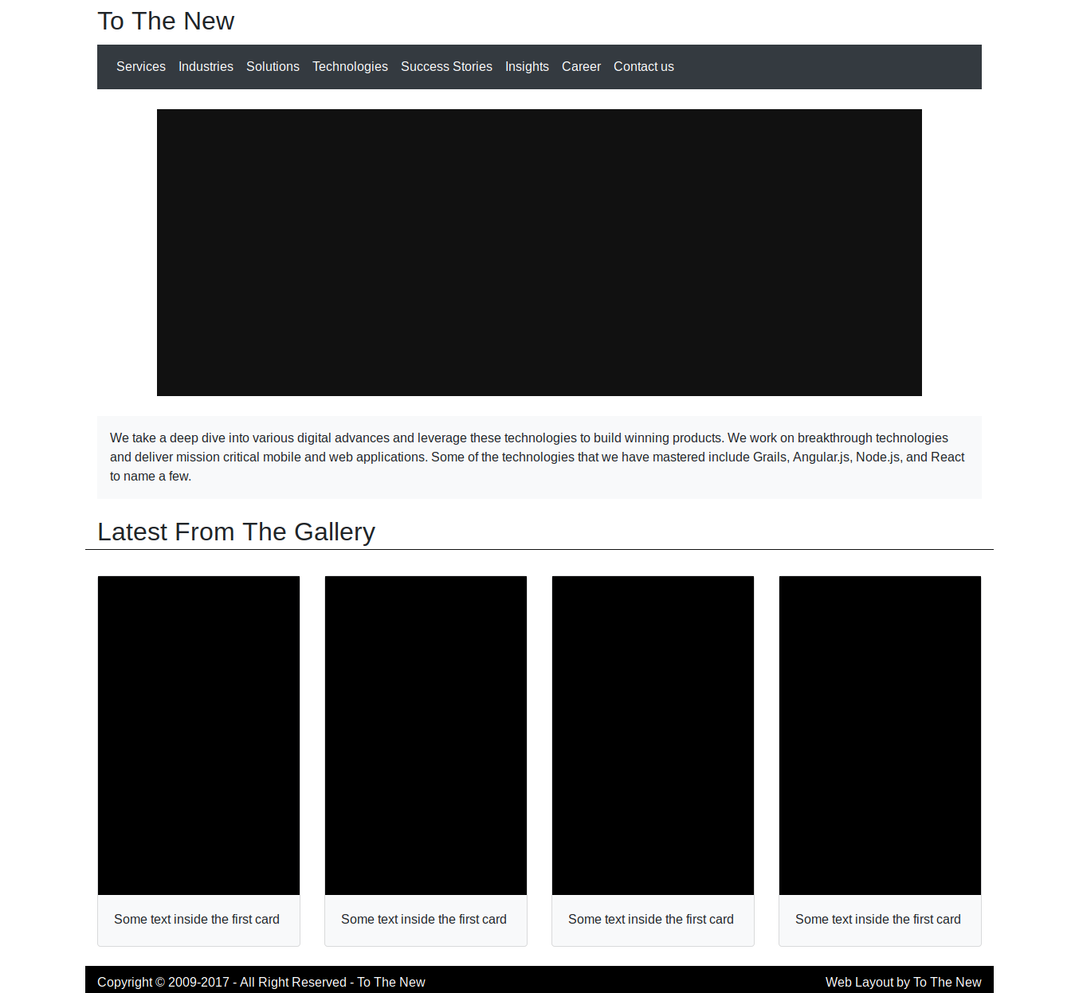

NOTE : Code for the following have been pushed along side with name “TtnFrontPage.html”

Ques 2 Create HTML for form.png using Bootstrap.

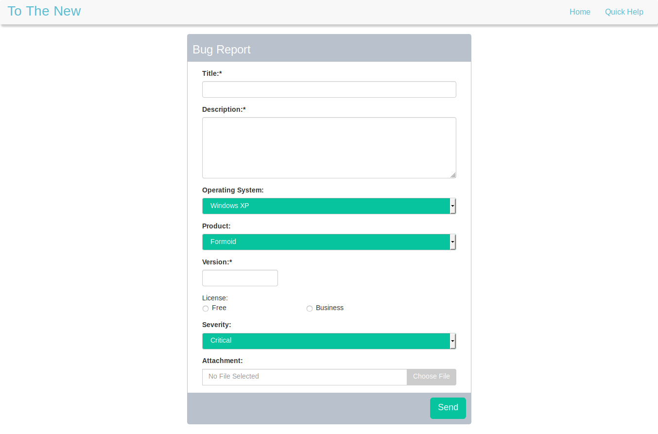

NOTE : Code for the following have been pushed along side with name “form.html” and “formstyle.css”